

Millcreek MetroParks and FirstEnergy Transmission Right-Of-Way are working together to develop pollinator fields throughout the area.

Youngstown Rotarian Troy Rhoades, an employee of FirstEnergy, became involved in Operation Pollination because of FirstEnergy’s initiatives with habitat restoration.

Nick Derico, Mill Creek MetroParks Natural Areas Manager and OP Partner, was interested in the potential of establishing pollinator fields on FirstEnergy right-of-way transmission lines on Mill Creek property in Canfield near the Vickers Preserve and in Boardman near Newport lake.

Rhoades and members of FirstEnergy’s vegetation management team have responsibility in finding and developing pollinator opportunities within the FirstEnergy footprint as well as construction and maintenance of the vegetation in the right-of-way corridors.

Derico met with the FirstEnergy team and discussed the properties and the desire to convert them to pollinator fields.

The meeting topics ranged from proposed locations, short- and long-term goals in the development, responsibilities from both parties, in-kind partnership, grant requests, etc.

Derico recommended the Canfield location be the first site to start with habitat restoration in early 2022, if possible. The consensus on the first step was that Mill Creek MP conduct a vegetation species survey to determine what species already exist in the field(s). Once determined, a follow up meeting will be held with this team to develop a short- and long-term strategy in converting this corridor into a full or hybrid pollinator/wetland field with a goal of completion in 2024.

This past weekend, Mahoning Land Bank and community volunteers helped install #3 of a series of habitat sites in the city. This site is at the corner of Garland and Oak St.
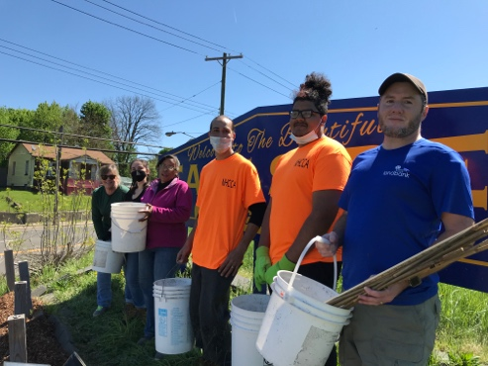
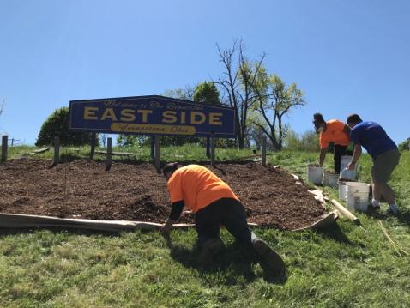

Operation Pollination is a community-engagement project to benefit The Environment – Rotary International’s seventh area of global focus. For more information, contact Elayne Bozick. emsbozick@gmil.com, 330 360-3799 or visit https://youngstownrotary.com/sitepage/operation-pollination

